МІНІСТЕРСТВО ОСВІТИ І НАУКИ УКРАЇНИ
НАЦІОНАЛЬНИЙ УНІВЕРСИТЕТ “ЛЬВІВСЬКА ПОЛІТЕХНІКА”

Кафедра систем штучного інтелекту


Лабораторна робота № 5
з дисципліни «Математичні методи дослідження операцій»

Виконав:
Студент групи КН-215
Лозовий Олег
Викладач:
Шиманський В. М.

Львів – 2023р.
Варіант №2
Тема: Формальна постановка транспортної задачі методом потенціалів.
Хід роботи:
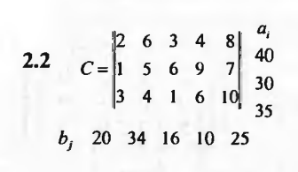

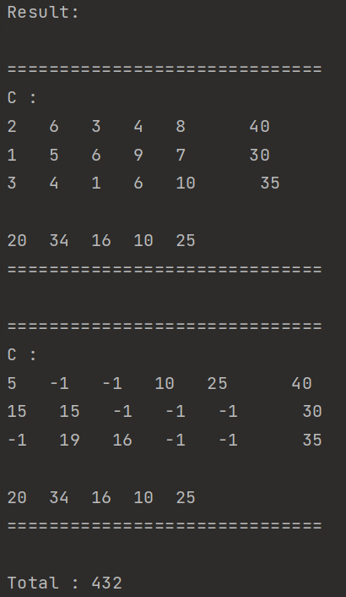
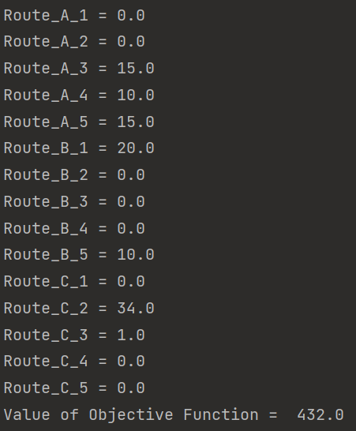

#include <bits/stdc++.h>
using namespace std;
vector<vector<long double>> C;
vector<vector<long double>> Plan;
vector<long double> a;
vector<long double> b;
vector<long double> U;
vector<long double> V;
vector<vector<long double>> delta;
vector<pair<int, int>> cycle;
int row_max;
int col_max;
void print_all(vector<vector<long double>> matrix, vector<long double> row, vector<long double> col) {
cout << endl;
for (int i = 0; i < 30; i++) cout << "=";
cout << endl << "C :" << endl;
for (int i = 0; i < matrix.size(); i++) {
for (int j = 0; j < matrix[i].size(); j++) {
cout << matrix[i][j] << " ";
}
cout << " " << col[i] << endl;
}
cout << endl;
for (int j = 0; j < matrix[0].size(); j++) {
cout << row[j] << " ";
}
cout << endl;
for (int i = 0; i < 30; i++) cout << "=";
cout << endl;
}
void check_balance() {
long double sum_a = 0;
for (int i = 0; i < a.size(); i++) sum_a += a[i];
long double sum_b = 0;
for (int i = 0; i < b.size(); i++) sum_b += b[i];
if (sum_a == sum_b) return;
else if (sum_b > sum_a) {
vector<long double> help;
help.assign(b.size(), 0);
C.push_back(help);
a.push_back(sum_b - sum_a);
} else if (sum_a > sum_b) {
for (int i = 0; i < a.size(); i++) {
C[i].push_back(0);
b.push_back(sum_a - sum_b);
}
}
}
void find_plan() {
vector<long double> help;
help.assign(C[0].size(), -1);
Plan.assign(C.size(), help);
vector<long double> tmp_a = a;
vector<long double> tmp_b = b;
int j = 0;
for (int i = 0; i < a.size(); i += 0) {
if (tmp_a[i] <= tmp_b[j]) {
Plan[i][j] = min(tmp_a[i], tmp_b[j]);
tmp_b[j] -= Plan[i][j];
tmp_a[i] = 0;
i += 1;
} else if (tmp_a[i] > tmp_b[j]) {
Plan[i][j] = min(tmp_a[i], tmp_b[j]);
tmp_a[i] -= Plan[i][j];
tmp_b[j] = 0;
j += 1;
}
}
long double q = 0;
for (int i = 0; i < a.size(); i++) q += tmp_a[i];
for (int i = 0; i < b.size(); i++) q += tmp_b[i];
if (q != 0) {
cout << "bida" << endl;
return;
}
print_all(Plan, tmp_b, tmp_a);
int n = 0;
for (int i = 0; i < a.size(); i++) {
for (auto x: Plan[i]) {
if (x != -1) n++;
}
}
cout << endl << "Opornyy plan - ";
if (n == a.size() + b.size() - 1) {
cout << "Nevirodgenyy" << endl;
} else {
cout << "Virodgenyy" << endl;
}
}
void calculate_potencials() {
U.assign(a.size(), -999);
V.assign(b.size(), -999);
int k = 1;
U[0] = 0;
while (k > 0) {
for (int i = 0; i < a.size(); i++) {
for (int j = 0; j < b.size(); j++) {
if (Plan[i][j] != -1) {
if (U[i] != -999 and V[j] == -999) {
V[j] = C[i][j] - U[i];
} else if (V[j] != -999 and U[i] == -999) {
U[i] = C[i][j] - V[j];
}
}
}
}
k = 0;
for (int i = 0; i < a.size(); i++) {
if (U[i] == -999) {
k++;
}
}
}
cout << endl << "U: ";
for (int i = 0; i < a.size(); i++) {
cout << U[i] << " ";
}
cout << endl << "V: ";
for (int i = 0; i < b.size(); i++) {
cout << V[i] << " ";
}
}
void calaculate_delta() {
vector<long double> help;
help.assign(b.size(), 0);
delta.assign(a.size(), help);
bool higer_zero = false;
for (int i = 0; i < a.size(); i++) {
for (int j = 0; j < b.size(); j++) {
if (Plan[i][j] == -1) {
delta[i][j] = U[i] + V[j] - C[i][j];
if (delta[i][j] > 0) higer_zero = true;
}
}
}
print_all(delta, b, a);
if (higer_zero) {
int row = 0;
int col = 0;
for (int i = 0; i < a.size(); i++) {
for (int j = 0; j < b.size(); j++) {
if (delta[i][j] > delta[row][col]) {
row = i;
col = j;
}
}
}
cout << endl << "row : " << row << " col : " << col << " max : " << delta[row][col] << endl;
col_max = col;
row_max = row;
}
}
void find_cycle() {
cycle.resize(1);
vector<pair<int, int>> checked;
cycle[0] = {row_max, col_max};
checked.push_back({row_max, col_max});
bool direction_row = true;
while (true) {
pair<int, int> last_elem = cycle[cycle.size() - 1];
if (cycle.size() > 3) {
if (last_elem.first == row_max or last_elem.second == col_max) {
cout << endl;
for (int i = 0; i < 100; i++) cout << "#";
cout << endl;
for (int i = 0; i < cycle.size(); i++) {
cout << "( " << cycle[i].first << ", " << cycle[i].second << " ) --> ";
}
cout << "( " << cycle[0].first << ", " << cycle[0].second << " )" << endl;
for (int i = 0; i < 100; i++) cout << "#";
cout << endl;
break;
}
}
bool swaped = false;
if (direction_row) {
int row = last_elem.first;
for (int j = 0; j < b.size(); j++) {
if (Plan[row][j] < 0) continue;
pair<int, int> point = {row, j};
bool in_cycle = false;
for (int i = 0; i < checked.size(); i++) {
if (checked[i] == point) {
in_cycle = true;
break;
}
}
if (in_cycle) continue;
direction_row = false;
cycle.push_back(point);
checked.push_back(point);
swaped = true;
break;
}
} else {
int col = last_elem.second;
for (int i = 0; i < a.size(); i++) {
if (Plan[i][col] < 0) continue;
pair<int, int> point = {i, col};
bool in_cycle = false;
for (int i = 0; i < checked.size(); i++) {
if (checked[i] == point) {
in_cycle = true;
break;
}
}
if (in_cycle) continue;
direction_row = true;
cycle.push_back(point);
checked.push_back(point);
swaped = true;
break;
}
}
if (!swaped) {
if (cycle.size() == 1) direction_row = !direction_row;
else {
cycle.pop_back();
direction_row = !direction_row;
}
}
}
}
void plusiki_minusiki_veselo_kapec() {
int min = INT_MAX;
for (int i = 1; i < cycle.size(); i += 2) {
pair<int, int> node = cycle[i];
if (min > Plan[node.first][node.second]) {
row_max = node.first;
col_max = node.second;
min = Plan[row_max][col_max];
}
}
int sign = 1;
for (int i = 0; i < cycle.size(); i++) {
if (Plan[cycle[i].first][cycle[i].second] == -1) Plan[cycle[i].first][cycle[i].second] = 0;
Plan[cycle[i].first][cycle[i].second] += min * sign;
sign *= -1;
}
Plan[row_max][col_max] = -1;
}
int main() {
a = {40, 30, 35};
b = {20, 34, 16, 10, 25};
C = {{2, 6, 3, 4, 8},
{1, 5, 6, 9, 7},
{3, 4, 1, 6, 10}};
// a = {100, 120, 150, 130};
// b = {140, 130, 90, 140};
// C = {{4, 5, 5, 7},
// {8, 7, 5, 4},
// {9, 6, 4, 5},
// {3, 2, 9, 3}};
print_all(C, b, a);
check_balance();
cout << "Balance checked" << endl;
print_all(C, b, a);
find_plan();
while (true) {
calculate_potencials();
calaculate_delta();
bool optimal = true;
for (int i = 0; i < a.size(); i++) {
for (int j = 0; j < b.size(); j++) {
if (delta[i][j] > 0) {
optimal = false;
break;
}
}
if (!optimal) break;
}
if (optimal) {
cout << endl << endl << "Result: " << endl;
print_all(C, b, a);
print_all(Plan, b, a);
int total = 0;
cout << endl;
for (int i = 0; i < a.size(); i++) {
for (int j = 0; j < b.size(); j++) {
if (Plan[i][j] != -1) {
total += Plan[i][j] * C[i][j];
}
}
}
cout << "Total : " << total << endl;
return 0;
}
find_cycle();
plusiki_minusiki_veselo_kapec();
}
}

